Contents

Analysis 1

Problem description 1

Research 1

# Analysis

## Problem description

New technology allows us to communicate with our friends around the world, and we can also play games with them from anywhere we like. Board games have been around for centuries and they’ve always had to be played in person - sat next to each other. Toby would like to play a game of chess with his friends; although they don’t live nearby, making it hard to play with anyone. Of course, this is easily fixed by making an online version of chess.

In the case there isn’t anyone available to play with – there are still 2 different offline options in order to play chess.

One of which is puzzles. You are given a position where you must play the best move in order to continue. Typically, they are about 3 to 5 moves long and can range in difficulty from beginner to grandmaster. This puzzle feature must have a search/rating feature so that you can play puzzles which aren’t too far out of your skill level.

The other option is to create an AI, this can be created in a few ways. The easier option is to use a popular algorithm called minimax (with alpha beta pruning) – this algorithm can be used to evaluate chess positions a few moves ahead and choose what it thinks provides the most advantage. The algorithm without any optimisations is fairly slow for chess; alpha beta pruning is a way of helping this; it compares the result with the current best one and will prune it if the evaluation is lower – meaning that it stops looking down that path as it is seemingly not worth the time.

And for the online aspect, you will have the option to be randomly paired with another player or you can choose the player to go up against. This allows you to play with your friends, but also if nobody you know is online to still have a game of chess available.

## 

## Research

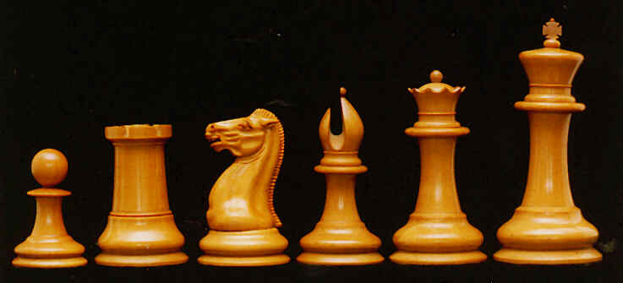In chess, there are 6 different pieces: pawn, rook, knight, bishop, queen, king (as shown respectively in Figure 1). Each move differently and have special rules in certain situations. I will use chess notation to help explain these rules and everything will be explained from white’s perspective

Figure – chess pieces

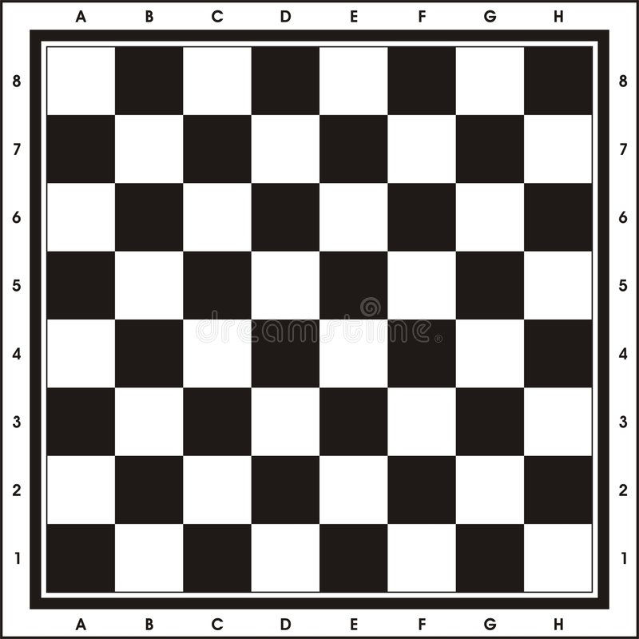The board

When referring to a chess board, we refer to a row as a rank, and a column as a file. For example, in the starting position, white pawns start on the second rank.

The bottom left is the coordinate A1, and the top right is H8. White’s pieces start with the ‘A’ file on the bottom left.

Chess notation

Each piece except for pawns are represented with a letter – K, N, Q, R, B. When a pawn moves, only the destination coordinate is noted down and when any other piece moves, the notation combines the destination square with the piece that has been moved. For example, Ke2 would be a king moving to the e2 square. Nf6 would be a knight moving to the f6 square. e4 would be a pawn moving to that square, with the context of which pawn being made clear in the game.

When a piece is captured, the coordinate the piece was captured on and the piece that captured it is notated with an ‘x’ in between. The pawn is once again an exception where the file the pawn was on is notated instead. Examples include: Bxe4 (bishop takes e4) or bxc5 (pawn on the ‘b’ file takes c5).

When the king is put into check, a ‘+’ is put at the end of the move. E.g. Qb5+.

Check and checkmate

When the king is attacked by an opposite coloured piece, it must move out of the attack. This can be done by either blocking the check or by moving into a square where it can’t be captured in the next move. If neither of these options is available and the king cannot be in a safe square, it is checkmate, and the opposing side wins.

The pieces

Each type of piece has their own set of moves. All pieces can’t capture their own colour, and they also can’t jump over anything – except the knight.

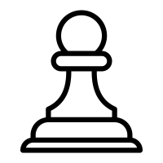Pawn

The pawn is one of the most complicated pieces on the board – with more rules than any other piece. Their starting square is on the second rank.

First, when on the starting square, it has the ability to move two squares forward. Therefore, each pawn has the ability to go from X2 to X3 or X4 – where X is any letter on the board. After a pawn has moved, they can only move one square forward.

Furthermore, when a pawn captures a piece, it does so diagonally. No matter where it is, it will always be able to capture one square diagonally forward to the left or right.

Also, pawns cannot move backwards in any way.

There is also a special rule called ‘en passant’. This means ‘in passing’ and was a rule made to disallow pawns from escaping capture. The rule goes like this: a horizontally adjacent pawn can be captured if it has just moved two squares in the previous move. The capturing pawn will move to the square that the advancing pawn passed over as if it had move 1 square.

When a pawn reaches the 8th rank, it can promote into any piece other than a pawn and king. This is called promotion – and must be stopped at all costs in a game of chess.

To describe this in context:

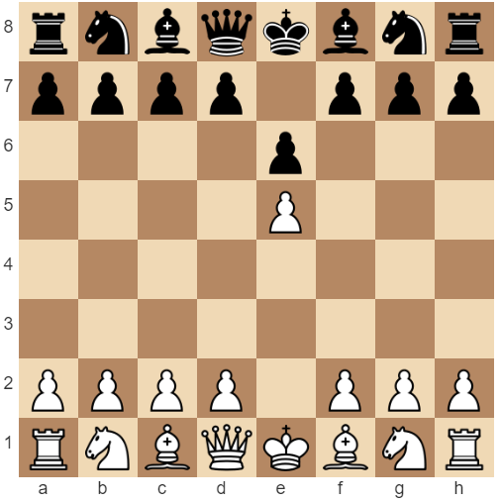In this position it is black to move

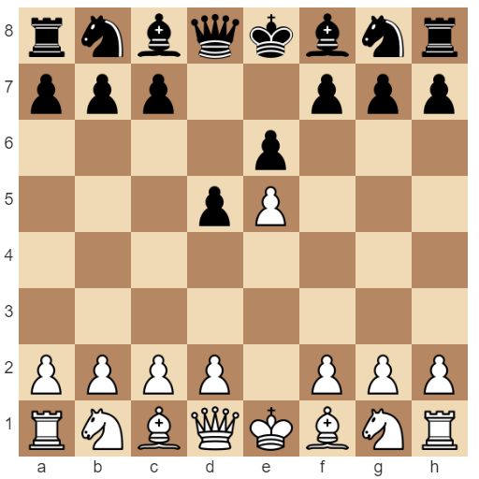

d5 is played. Placing the pawns horizontally adjacent to each other

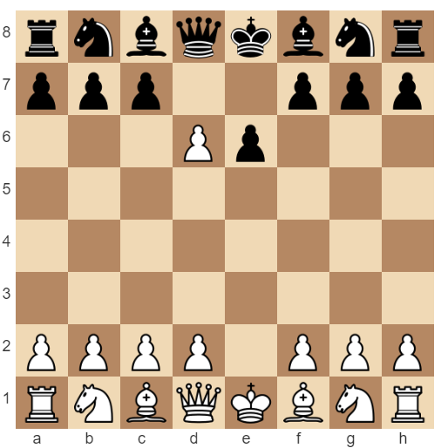

exd6 is played. Capturing the black pawn.

If white was to not play exd6, it would not be available on the next move, thus en passant would no longer be available.

Rook

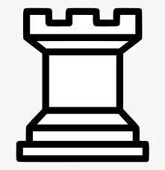The rook can only move along a file or rank any number of squares that’s available.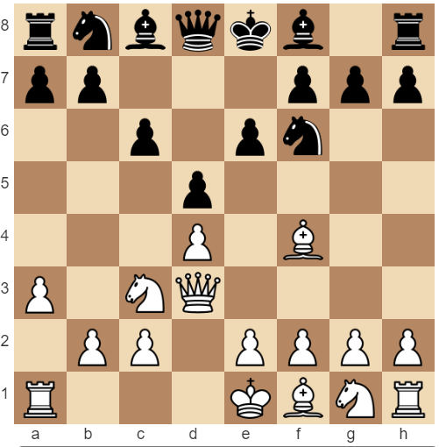 Here, the a1 rook can move anywhere from b1 to d1 and also to a2.

Knight

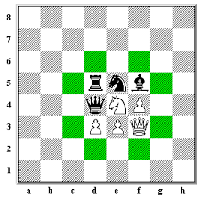The knight moves in an ‘L’ shape in any direction, giving it 8 available moves.

As shown in figure 2, the knight can jump 2 squares forward/backward and 1 to the side; or 2 squares to the side and 1 square down/up – ignoring any pieces that are around it.

Figure 2 - Knight moves

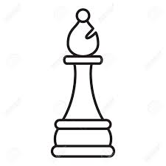Bishop

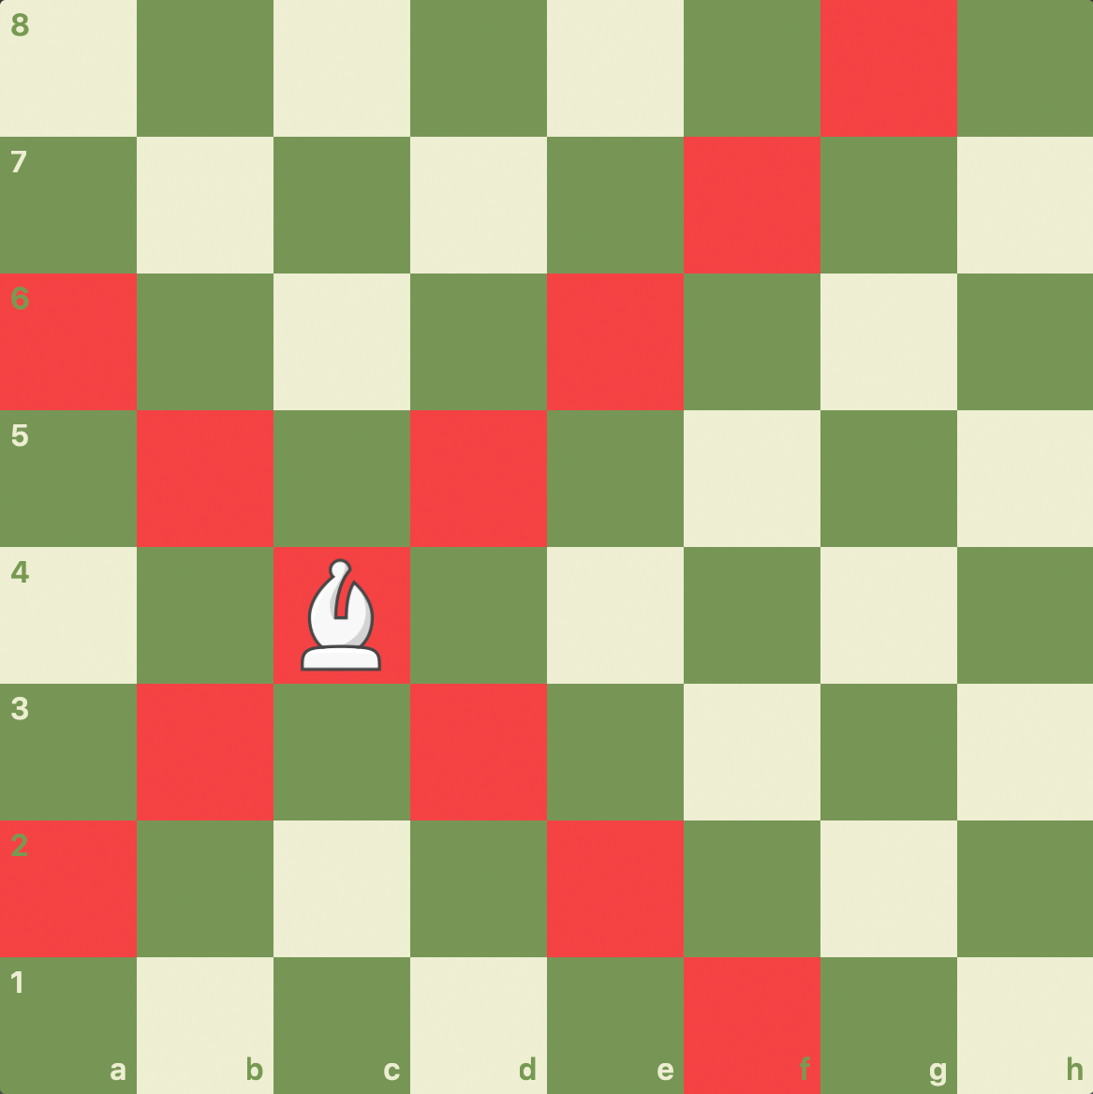

Figure 3 - Bishop moves

The bishop can move anywhere along a diagonal as shown in figure 3; it will never change the colour of it’s square.

Queen

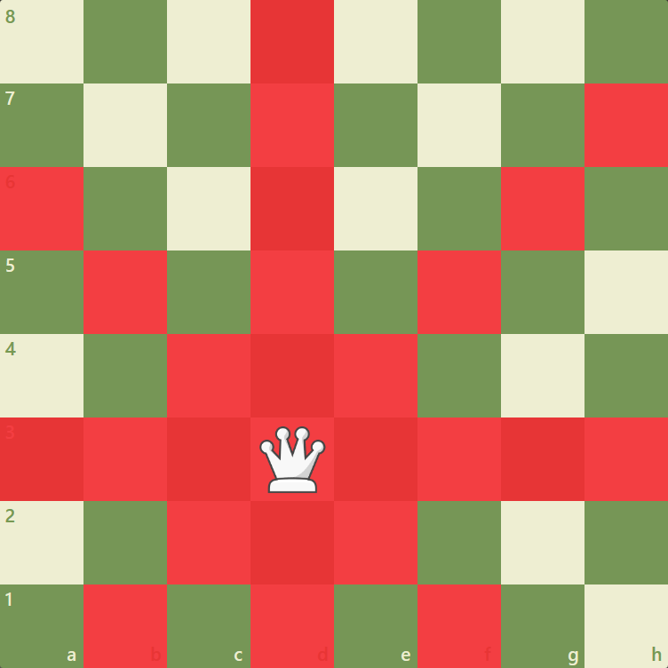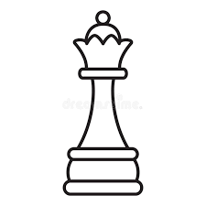The queen has the ability to move along all diagonals and also all files/ranks. It inherits both the movements of the bishop and the rook – making it the most powerful piece in chess.

King

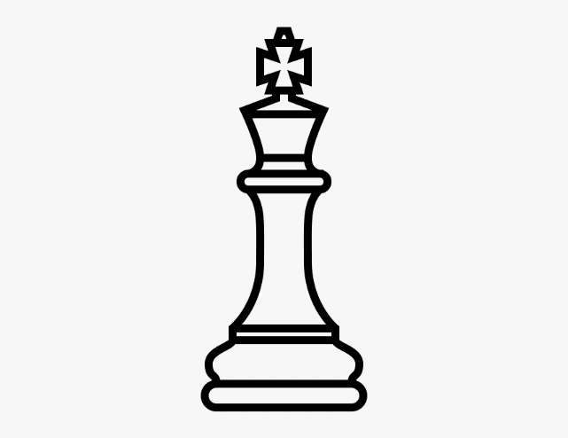

The king is the most restricted piece on the board. There are many different cases for what a king can/can’t do:

The king is capable of moving in every direction by 1 square.

The king cannot move into a square that is attacked by an opposite coloured piece; If it can be captured on the next move - it isn’t allowed.

Check and checkmate apply to the king – see earlier paragraph.

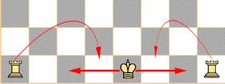There is a move called castling – if there are no pieces in between the king or either rook, and the rook nor the king have been moved, you can move the king 2 squares across and move the rook over the king and next it.

Figure - Castling

As shown here in figure 4, since there is nothing in the way, castling is available.

However, you cannot castle if the king has to move through a check (but the rooks can move through the check).

## Further research

Making the chess website as similar to real life as possible is a big aim. So, the requirements given by my client will help me make these decisions.

Time control

In chess, there are many different ways of playing the game, namely in terms of how much time you have. Each time control completely changes the way the game is played. The 5 popular time controls are: Blitz, these typically last 3 minutes or 5 minutes; Bullet, this will last 1 minute; Classical, will last 30 minutes minimum but - in professional chess - it is 90 mins and bonus-time is added after move 30; Rapid, which is a 10-minute game; and the last most unpopular mode – UltraBullet, lasting only 30 seconds. Each player will get a timer and when it is your move, your timer counts down. When a player’s timer hits 0 seconds, the game is lost.

There is additionally an option to add extra time after each move. For example, 3-minute blitz games are popularly played with 2 seconds bonus; this means every time you make a move, 2 seconds is added to your timer. The time control in question is referred to as ‘3+2’, and a 5-minute game with no bonus will be referred to as ‘5+0’ and so on.

A different play style is required for each time control, with the lower time controls requiring quick thinking and sharpness, and the long classical games being made for long-thinkers, who are trying to find the absolute best move each turn.